Refund Policy
APP & SAAS TEMPLATE

Last updated: [EFFECTIVE DATE]
This Refund Policy explains how [COMPANY NAME] handles refunds, cancellations and billing disputes for [APP NAME] and for plans bought through [WEBSITE URL]. It applies to purchases made on or after [EFFECTIVE DATE].
It covers paid subscription plans, one off licence purchases, in-app purchases and add on credits. Read it together with our terms of service, which set out how accounts, plans and billing work.
Where you bought through an app store, that store's own refund rules govern the transaction and take priority over this policy for that payment.
Contents
1. Scope Of This Policy 2
2. Purchases Through App Stores 2
3. Refunds On Direct Purchases 2
4. Monthly And Annual Plans 2
5. Free Trials And Cancellation 3
6. Downgrades And Plan Changes 3
7. Service Outages And Credits 3
8. Chargebacks And Disputes 3
9. Your Statutory Rights 4
10. How To Contact Us 4
How to use this template
1. Replace every [PLACEHOLDER] with your own details. Use Find and Replace in Word to catch them all.
2. Delete any section that does not apply to your business, and renumber the headings that follow.
3. Have the finished document reviewed by a qualified lawyer in [COUNTRY/STATE] before you publish it.

1. Scope Of This Policy
This policy applies to paid access to [APP NAME] and to any related service sold by [COMPANY NAME]. It covers monthly and annual subscriptions, in-app purchases, consumable credits and one off licence fees.
It does not cover charges made by a third party, such as your mobile network, an implementation partner, or a reseller that issued its own invoice. Ask that party for a refund of the amount it charged you.
Prices, invoices and refunds are handled in [CURRENCY] unless your invoice states another currency.

2. Purchases Through App Stores
If you subscribed or made an in-app purchase inside [APP NAME] on an Apple device, Apple is the seller of record and processes the payment. Refund requests for those transactions must be made to Apple through its report a problem process, and Apple decides the outcome under its own rules.
The same applies to purchases made through Google Play. Google handles billing, refunds and cancellation for a Play subscription, and its published refund policy governs the request.
We cannot issue, reverse or speed up a store refund, and we have no access to your store payment details. We can confirm what your account shows and provide usage records to support your request to the store.

3. Refunds On Direct Purchases
For subscriptions and licences bought directly from [COMPANY NAME] at [WEBSITE URL], you may request a refund within [NUMBER] days of the initial charge. Send the request to [CONTACT EMAIL] from the email address registered on the account.
This clause covers the first payment for a new plan. Renewal charges taken after the first billing period are handled under sections 4 and 5.
We may decline a request where the account shows use well beyond an evaluation, where the plan was bought under a discount marked as non-refundable, or where the same account has already received a refund for the same product.

4. Monthly And Annual Plans
Monthly plans renew each month until cancelled. If a renewal is charged and you no longer want the service, cancel the plan. We do not refund part of a monthly charge for the days you did not use, because access continues to the end of the paid month.
Annual plans are charged in advance for the full term. If you cancel part way through an annual term, access continues until the term ends and no partial refund is made, unless the law of [COUNTRY/STATE] requires one.
Where we cancel or suspend a paid account for a reason other than a breach of our terms, we refund the unused portion of the current term on a pro-rata basis.
We send a renewal reminder before an annual charge to the email address on the account. Keep that address current so the reminder reaches you.

5. Free Trials And Cancellation
A free trial gives access for the stated period. Cancel before the trial ends to avoid a charge. If a trial converts to a paid plan and you did not intend to continue, contact [CONTACT EMAIL] within [NUMBER] days of the charge and we will review it.
Cancelling and refunding are different actions. Cancelling stops the next charge and leaves your access running until the end of the period you have already paid for. A refund returns money already taken and normally ends access straight away.
You can cancel at any time from the billing screen in [APP NAME] or through [SUPPORT URL]. A subscription bought in an app store must be cancelled in that store's subscription settings, because deleting the app does not stop billing.

6. Downgrades And Plan Changes
When you move to a cheaper plan, the change takes effect at the start of the next billing period. We do not refund the price difference for the remainder of the period you have already paid for.
When you upgrade during a term, we charge the difference for the time remaining in the current period and apply the new plan immediately.
Reducing seats, licences or usage limits follows the same rule as a downgrade. Removed seats stop being billed from the next renewal date and are not credited mid term.

7. Service Outages And Credits
If [APP NAME] is unavailable for an extended period because of a fault on our side, you may request a service credit. Send the request to [CONTACT EMAIL] within [NUMBER] days of the outage, with the dates and times affected.
Credits are applied against a future invoice and are not paid out in cash. A credit is the remedy we offer for downtime, in place of a refund of the affected period.
Downtime caused by maintenance we announced in advance, by your own network, devices or configuration, or by a third party service you connect to [APP NAME], does not qualify for a credit.

8. Chargebacks And Disputes
Contact us before you raise a chargeback with your bank or card issuer. Most billing problems are resolved faster by email than by a formal dispute, which can take several weeks to close.
When a chargeback is opened we may suspend the account until the dispute is resolved, and we will supply the payment processor with account, invoice and usage records.
Where a dispute is decided in our favour, we may require payment of the fee charged to us by the processor before access to the account is restored.

9. Your Statutory Rights
Consumers in the European Union and the United Kingdom have a right to withdraw from most distance contracts within 14 days. For digital content and services, that right can end once you agree to immediate access and acknowledge the loss of the withdrawal right, which happens when you start using a paid plan straight away.
Consumers in Australia, Canada and other countries hold rights under their own consumer law that a contract cannot remove. Nothing in this policy limits those rights.
Business customers buying under an order form or master agreement are covered by the refund terms in that document where it conflicts with this policy.

10. How To Contact Us
Send refund, cancellation and billing questions to [CONTACT EMAIL], or open a ticket at [SUPPORT URL]. Include the account email address, the invoice number and the date of the charge.
Written correspondence can be sent to [COMPANY NAME], [POSTAL ADDRESS]. We aim to respond to refund requests within [NUMBER] business days.
Before you publish
Replace every placeholder in square brackets with your own details before you publish this policy, and remove any clause that does not match how you charge for [APP NAME]. App store rules, trial conversion rules and consumer withdrawal rights change often and differ by country. Ask a qualified lawyer in [COUNTRY/STATE] to review the final text before you rely on it.
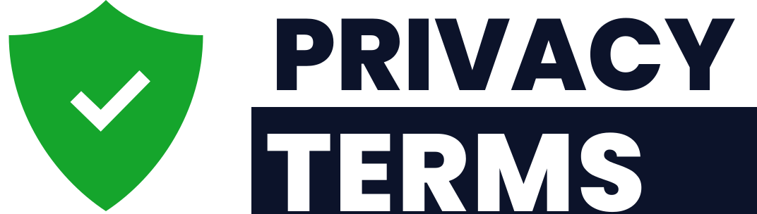
Free template provided by PrivacyTerms.io. Drafting legal documents since 2013.
Need a version written around your business? Build a tailored document in minutes at privacyterms.io

