Privacy Policy
APP & SAAS TEMPLATE

Last updated: [EFFECTIVE DATE]
This Privacy Policy explains how [COMPANY NAME] collects, uses, and shares personal information when you download, install, or use [APP NAME], and when you use the connected service and account pages at [WEBSITE URL].
It covers the mobile app, the web dashboard, billing, and the help channels at [SUPPORT URL]. It does not cover a third party service you connect to [APP NAME], which handles your data under its own policy.
[COMPANY NAME] is based in [COUNTRY/STATE] and controls the information described here. This version applies from [EFFECTIVE DATE].
Contents
1. Who We Are 2
2. Account Information 2
3. Device Data And Permissions 2
4. SDKs And Analytics 2
5. Purchases And Billing 3
6. App Store Disclosures 3
7. Sharing With Sub-processors 3
8. Deletion, Export, Retention 4
9. Children And Age Ratings 4
10. Transfers, Changes, Contact 4
How to use this template
1. Replace every [PLACEHOLDER] with your own details. Use Find and Replace in Word to catch them all.
2. Delete any section that does not apply to your business, and renumber the headings that follow.
3. Have the finished document reviewed by a qualified lawyer in [COUNTRY/STATE] before you publish it.

1. Who We Are
[COMPANY NAME] publishes [APP NAME] on the Apple App Store and Google Play, and runs the connected service at [WEBSITE URL]. Our postal address is [POSTAL ADDRESS] and our privacy contact is [CONTACT EMAIL].
Where we handle data inside a business customer's workspace, that customer decides how the data is used and we act on its instructions. Our agreement with that customer governs the processing.

2. Account Information
You create an account to use [APP NAME]. We collect your name, email address, a stored password hash, and any profile details you add, such as a photo, time zone, or organisation name.
If you sign in with Apple, Google, or another identity provider, we receive the account identifier and email address that provider releases to us. We never receive your password for that provider.
We also store the content you create in the app, including documents, notes, uploads, and settings. That content stays yours. We access it only to operate the service, to work on a support ticket you opened, or to meet a legal duty.

3. Device Data And Permissions
[APP NAME] records technical data from your device so the app runs correctly and stays secure. This includes device model, operating system version, app version, language, network type, crash state, and a resettable vendor or advertising identifier.
The app asks before it uses a sensitive device feature. You can refuse, and you can change the answer later in your device settings. Refusing a permission disables only the feature that depends on it.
• Camera and photo library, used to capture or attach images inside [APP NAME].
• Location, used to show nearby results, and only while the app is open unless you allow background access.
• Contacts, read at the moment you pick someone to invite and not uploaded in bulk.
• Microphone, used for voice notes and calls you start.
• Notifications, which create a push token tied to your device so we can deliver alerts.
• Files and local storage, used to import and export your own documents.

4. SDKs And Analytics
[APP NAME] includes third party software development kits. Each one receives limited data to do a defined job. We keep the current list on the privacy screen inside the app and update it when a vendor is added or removed.
On Apple devices we use the App Tracking Transparency prompt before any kit tracks you across other companies' apps or websites. If you decline, we do not share the advertising identifier with those kits.
• Product analytics, which records screens viewed, features used, and session length against a pseudonymous identifier.
• Crash and performance reporting, which sends stack traces, device state, and app version when [APP NAME] fails.
• Push delivery, which uses the notification token issued by Apple or Google.
• Support messaging, which links a conversation to your account.
• Attribution and advertising kits, which run only if you allow tracking.

5. Purchases And Billing
[APP NAME] offers paid plans and in-app purchases. Purchases made inside the mobile app are processed by Apple or Google under their own terms. They confirm that a purchase succeeded, which plan you bought, and when it renews. They do not pass us your full card number.
Purchases made on the web are handled by our payment provider, which processes card details on its own systems. We store the plan, the [CURRENCY] amount, the invoice, the billing country, and the last four digits of the card for accounting.
We keep invoices and tax records for the period required by law in [COUNTRY/STATE], including after you close your account.

6. App Store Disclosures
Apple requires a privacy nutrition label and Google requires a Data safety section. Both summarise the data types [APP NAME] collects, whether that data is linked to your identity, and whether any of it is used to track you.
We keep those store disclosures aligned with this policy. This policy describes our actual practice, and we correct a store listing that falls behind. A store listing reflects a specific build, so an older installed version may show older entries.

7. Sharing With Sub-processors
We do not sell personal information, and we do not share it for cross context behavioural advertising unless you opt in. We do rely on sub-processors that store or process data on our behalf.
Each sub-processor is bound by contract to use the data only for the service it supplies to us. We provide the current list on request at [CONTACT EMAIL] and give business customers notice before we add a new one.
• Cloud hosting and database providers that run the backend for [APP NAME].
• Email and push delivery services that send transactional messages.
• Analytics, crash reporting, and error monitoring vendors.
• Payment and subscription management providers.
• Support desk and ticketing tools behind [SUPPORT URL].
• Authorities, advisers, or a successor business where the law or a transaction requires it.

8. Deletion, Export, Retention
You can delete your account inside [APP NAME] under account settings, or from your account page at [WEBSITE URL]. Deletion removes your profile, your content, and your push tokens from live systems within [NUMBER] days. Encrypted backups clear on their normal cycle.
You can export your data from the same screen at any time. The export is a machine readable file holding your account details and the content you created.
Uninstalling the app does not delete your account. Information held on our servers remains until you ask us to delete it or the account expires. Information stored only on the device is removed when you uninstall, subject to your own device backups. We keep anonymised statistics that cannot identify you.

9. Children And Age Ratings
[APP NAME] is not intended for children under [NUMBER] and we do not knowingly collect their personal information. Where COPPA applies in the United States, we do not collect information from a child under 13 without verifiable parental consent.
Our Apple age rating and Google content rating describe the intended audience of the app. If we learn that a child created an account, we close it and delete the data. A parent or guardian can write to [CONTACT EMAIL] to ask us to remove a child's information.

10. Transfers, Changes, Contact
Our sub-processors operate in more than one country, so your data may be processed outside [COUNTRY/STATE]. For transfers from the EU, the UK, or Switzerland we rely on standard contractual clauses, the UK addendum, or an adequacy decision. Ask [CONTACT EMAIL] which safeguard covers a specific vendor.
We update this policy when [APP NAME] changes or the law changes. We publish the new version at [WEBSITE URL], change the date shown at the top, and display an in-app notice for a material change.
Contact [COMPANY NAME] at [CONTACT EMAIL], through [SUPPORT URL], or by post at [POSTAL ADDRESS]. Under the GDPR, the UK GDPR, the CCPA and CPRA, PIPEDA, or the Australian Privacy Act, you can also complain to the regulator where you live.
Before you publish
This template is a starting point and not legal advice. Replace every placeholder in square brackets with your own details, remove any clause that does not match how [APP NAME] works, and ask a qualified lawyer in [COUNTRY/STATE] to review the finished policy before you publish it or submit it to an app store.
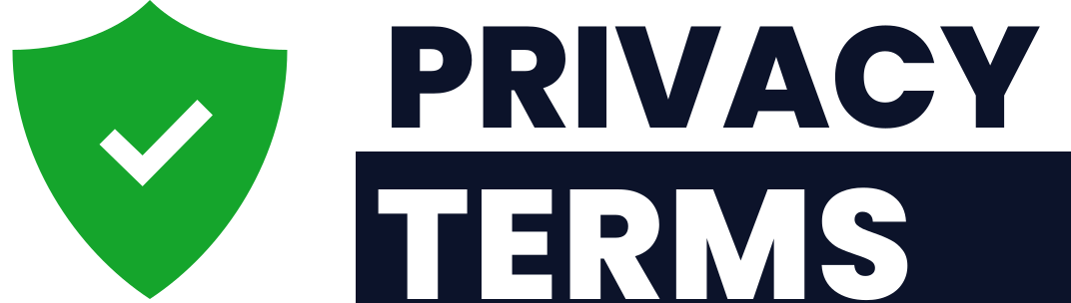
Free template provided by PrivacyTerms.io. Drafting legal documents since 2013.
Need a version written around your business? Build a tailored document in minutes at privacyterms.io

