End User Licence Agreement
MOBILE APP TEMPLATE

Last updated: [EFFECTIVE DATE]
This End User Licence Agreement explains the terms on which [COMPANY NAME] licenses [APP NAME] to you. It covers the mobile app, the content inside it, and any updates delivered through an app store. It takes effect on [EFFECTIVE DATE].
[APP NAME] is licensed to you, not sold. You receive a limited right to use it on devices you own or control.
By downloading, installing, or using [APP NAME], you accept these terms. If you do not accept them, delete the app from your devices.
Contents
1. Parties To This Agreement 2
2. Licence Scope And Store Rules 2
3. Devices And Family Sharing 2
4. Purchases And Subscriptions 2
5. Licence Restrictions 3
6. Ownership And Third Party Services 3
7. Maintenance And Support 3
8. Warranty And Product Claims 3
9. Third Party Beneficiary Rights 4
10. Legal Compliance And Contact 4
How to use this template
1. Replace every [PLACEHOLDER] with your own details. Use Find and Replace in Word to catch them all.
2. Delete any section that does not apply to your business, and renumber the headings that follow.
3. Have the finished document reviewed by a qualified lawyer in [COUNTRY/STATE] before you publish it.

1. Parties To This Agreement
This agreement is between you and [COMPANY NAME]. It is not an agreement with Apple Inc., Google LLC, or any other app store operator.
[COMPANY NAME] is solely responsible for [APP NAME] and for its content. App store operators distribute the app. They do not develop it and they are not a party to this agreement.
Your use of an app store account is also covered by that store's own terms, which you accept separately with the store.

2. Licence Scope And Store Rules
[COMPANY NAME] grants you a non-transferable licence to use [APP NAME] on any device that you own or control, as permitted by the Apple App Store Usage Rules or the Google Play terms that applied to your download.
The licence is for personal, non-commercial use unless your plan states otherwise. It does not allow you to make the app available over a network where more than one device can use it at the same time.
Where the Apple App Store Usage Rules and this agreement conflict, the Usage Rules apply to your use of the app on Apple devices.

3. Devices And Family Sharing
You may install [APP NAME] on devices linked to your app store account, subject to the device limits set by that store.
Where family sharing is enabled by the store, members of your family group may download the app on their own devices. Each member needs a separate account inside [APP NAME] and must follow these terms.
Paid features tied to a single account are not shared through family sharing unless the store or your plan allows it. You are responsible for use of the app by anyone in your family group under the age of [NUMBER].

4. Purchases And Subscriptions
In-app purchases and subscriptions are billed by the app store, not by [COMPANY NAME]. Prices are shown in [CURRENCY] before you confirm a purchase.
Subscriptions renew automatically at the end of each billing period unless you cancel before renewal in your app store account settings. Cancellation is handled by the store, not inside the app.
• Refunds are handled by the app store under its own refund policy.
• Deleting the app does not cancel a subscription.
• A free trial converts to a paid subscription unless it is cancelled before the trial ends.
• Purchased content stays available only while your account and subscription remain active.
• Price changes take effect at the next renewal after the store notifies you.

5. Licence Restrictions
You agree not to do any of the following with [APP NAME] or with your account.
• Copy, modify, or create derivative works of the app, except where law permits it.
• Reverse engineer, decompile, or attempt to extract the source code of the app.
• Rent, lease, sell, sublicense, or transfer the app or your account access to another person.
• Run the app on a jailbroken or rooted device, or bypass app store security controls.
• Use automated tools to scrape, overload, or interfere with the app or its servers.
• Upload unlawful, infringing, or harmful content through the app.

6. Ownership And Third Party Services
[COMPANY NAME] and its licensors own [APP NAME], including its code, design, branding, and content. You receive a licence only, and all rights not expressly granted are reserved.
The app uses third party services and software development kits for functions such as analytics, crash reporting, payments, maps, and push notifications. Those providers process limited data under their own terms and privacy notices.
The app may link to third party sites or content. [COMPANY NAME] does not control that material and is not responsible for it. Content you create in the app stays yours.

7. Maintenance And Support
[COMPANY NAME] is solely responsible for maintenance and support of [APP NAME]. App store operators have no obligation to provide any maintenance or support for the app.
Support is available through [SUPPORT URL] and at [CONTACT EMAIL]. We aim to respond to support requests within [NUMBER] business days.
We release updates through the app store. Older versions of the app may stop working when server side changes are made, so keeping the app up to date is your responsibility.

8. Warranty And Product Claims
[APP NAME] is provided on an as is basis. To the extent permitted by law, [COMPANY NAME] excludes implied warranties, including fitness for a particular purpose and uninterrupted or error free operation.
If the app fails to conform to a warranty that applies, you may notify Apple, and Apple may refund the purchase price of the app. To the maximum extent permitted by law, Apple has no other warranty obligation for the app.
[COMPANY NAME] is responsible for handling any claim that [APP NAME] fails to meet a legal requirement, or that it infringes a third party intellectual property right. Send claims of that kind to [CONTACT EMAIL]. App store operators are not responsible for addressing them.
To the extent permitted by law, our total liability for any claim connected with the app is limited to the amount you paid for it in the [NUMBER] months before the claim arose.

9. Third Party Beneficiary Rights
Apple Inc. and its subsidiaries are third party beneficiaries of this agreement. When you accept these terms, Apple has the right to enforce them against you as a third party beneficiary.
This clause applies to copies of [APP NAME] downloaded from the Apple App Store. It does not create any obligation owed by Apple to you under this agreement.

10. Legal Compliance And Contact
You confirm that you are not located in a country subject to a government embargo and that you are not named on any restricted party list. You must follow applicable export control laws when you download or use the app.
This agreement is governed by the laws of [COUNTRY/STATE], unless local consumer law gives you rights that cannot be excluded by contract.
Send questions and notices to [CONTACT EMAIL] or to [COMPANY NAME] at [POSTAL ADDRESS]. Further information is published at [WEBSITE URL]. Billing, refund, and account issues handled at store level must be raised with the app store that sold you the app.
Before you publish
This template is a starting point only. Have it reviewed by a qualified lawyer in your jurisdiction, check it against current Apple and Google store requirements, and replace every placeholder in square brackets with your own details.
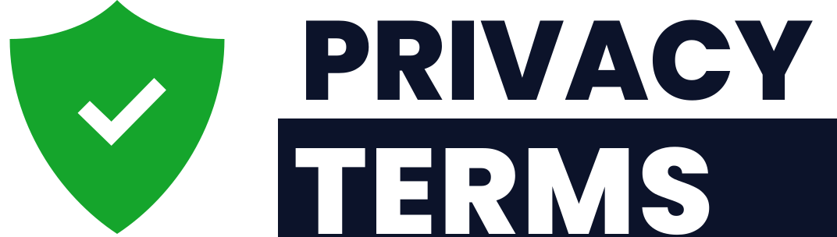
Free template provided by PrivacyTerms.io. Drafting legal documents since 2013.
Need a version written around your business? Build a tailored document in minutes at privacyterms.io

